Department Groups Screen
  - Purpose
    - This screen manages the information of different Department groups.
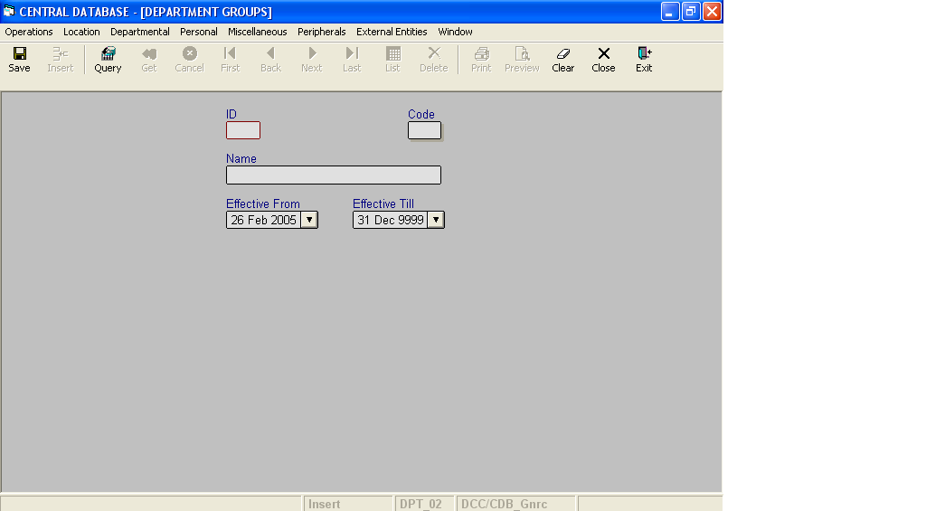

Layout as seen on opening of the Screen
  - Events associated
None
  - Modes
    - It will start in Insert mode.
    - It supports Insert, Query, Retrieve, Browse, List, New, Update and Reference modes.
  - Field specifications
i. Simple Fields
 | Type | Length | Optional | Insert Mode | Query Mode | BrowseMode
ID | department_group_id | 2 | N | N.A. | Allow | Display
Code | char | 2 | N | Allow | Allow | Allow
Name | varchar | 30 | N | Allow | Allow | Allow
Effective From | datetime | 8 | N | Allow | Allow | Allow
Effective Till | datetime | 8 | N | Allow | Allow | Allow
- Tabular Field Items

 | Type | Insert Mode | Query Mode | Browse Mode
Dept. Code | Key | N.A | N.A | Display
Department Name | Key | N.A | N.A | Display
Dept. ID | Key | N.A | N.A | Display

  - Simple Fields
    - ID
      - This is the Department Group ID, which uniquely identifies all the items.
      - This field will be automatically generated by the system.
      - The user will be informed of the generated ID as part of the message which will be shown on successful saving of information in Insert Mode.
    - Code
      - This is the code of the Department Group.
      - It is user defined. It can be changed in Browse and Update Modes.
      - Department Group code is uniquely defined in the database.
    - Name
      - This is the name of the Department Group.
      - It is user defined. The name can be changed in Browse and Update Modes.
      - Department Group name is uniquely defined in the database.
    - Effective From
      - This is the date since which Department Group is effective.
      - By default, the system will display the current date in Insert Mode.
      - Normally, it should not be a future date. This is the recommendation. System will display a warning, if future date is specified.
      - It cannot be later than the date specified in Effective Till.
    - Effective Till
      - This is the date till which a Department Group is effective.
      - By default, the system will display 31-Dec-9999 in Insert Mode.
      - Normally, it should not be a past date.
      - It cannot be earlier than the date specified in Effective From.

f. Tabular Field Items
i. Dept. Code
a) It is the code of the Department, which comes under the Department Group.
ii. Department Name
a) It is the name of the Department, which comes under the Department Group.
iii. Dept. ID
a) It is the ID of the Department, which comes under the Department Group.

g. Action Buttons
None
h. Users / User Roles
CDB_Gnrc user is permitted to insert, update, delete and select Department Group.
i. Other Considerations
None

